Low Level Design (add product module)

Project Code | Team1
Project Name | Expense Management System

Prepared/Modified by | Role | Date of Preparation
Ayush Choudhary | Software Engineer | 05/12/2018
Reviewed by | Role | Date of Review
 |  | 11/12/2018
Approved by | Role | Date of Approval
Circulation List | sumit.chuahan@capgemini.com  ayush.shrivastava@capgemini.com  ayush.a.choudhary@capgemini.com  rakesh.sangadikar@capgemini.com  yogesh.chacherkar@capgemini.com  shivani.jain@capgemini.com  deepesh.vishwakarma@capgemini.com  komal.b.pawar@capgemini.com | Version Number of the template:1.0
Version Number | 1.0

Table of Contents

1. Description Of The Unit 3
2. References 4
3. Dependencies / Assumptions 5
4. Class Diagrams 6
5. Sequence Diagrams 7
6. Design Components 8
6.1 List Of UI Components 8
6.2 List Of Design Classes 8
7. Re-Usable Routines/Components 9
8. Messages 10
9. Configuration Files 11
10. Crud Matrix Table 12
11. Data Mapping Matrix 13
12. Action Flow Matrix 14
13. Stored Procedures 15
14. Program Specification / Pseudo Code 16
REVISION HISTORY OF THE WORK PRODUCT 17

Description Of The Unit

The add product module allows the admin of the application to add new products into the database. This module can be used only by the admin of the application.

On clicking on the add button in the admin home page, the admin is redirected to a add page. The admin enters all the details of the product like product name, product description, product sub-category, product price, product quantity and product image. If the entered product details are invalid, appropriate error messages are displayed.

After entering all the product details, the details are inserted into the database on clicking the add button. The admin can also cancel the add product functionality by clicking on the cancel add button.

References

Reference | Description
Repository reference | https://IGTEBLRSVNTNG.igatecorp.com/svn/oct3_Team1
Class Diagram | /Project Documents/Design Documents/HLD/Class Diagrams
URS | /Project Documents/Requirements/Case Study/Ecommerce-grp1 and grp3.doc
UTP | /Project Documents/Test Plan/UTP/Test Cases/AddProduct /UTP_AddProductModule.xlsm
DB Design | /Project Documents/Design Documents/HLD/DB Design/E-Commerce_GROUP_DBDESIGN.xls

Dependencies / Assumptions

Assumptions:
The Employee details are stored in the database.

Class Diagrams

Class Diagram

Sequence Diagrams

Sequence Diagram
NA

Design Components

List Of UI Components
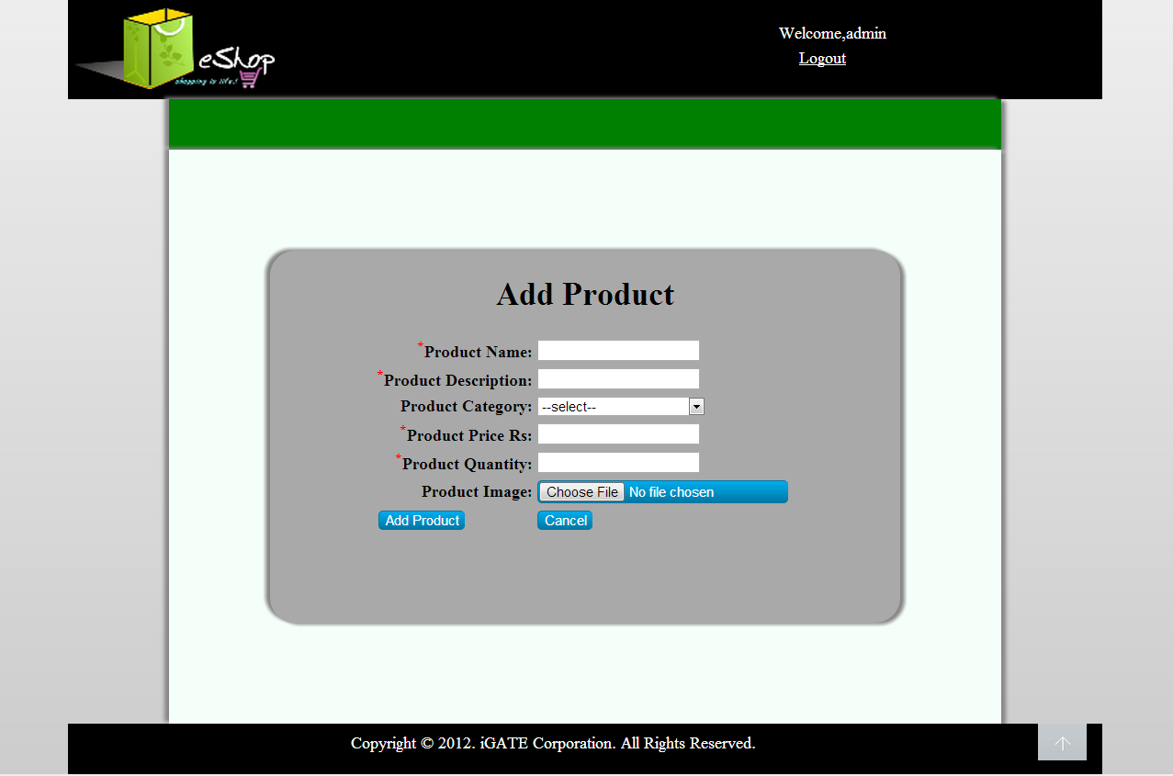

List Of Design Classes
Sr. No. | LLD Name | Class Name | Method Name | Method Description
1 | Add Product Module | Product,  ProductImage,  SubCategory | Appropriate getters and setters methods | Getters retrieve the property values and setters set the property values
2 | Add Product Module | EshopController | prepareAdd(Model model):String  processAddPage(@RequestParam("file") String filename,@ModelAttribute("Product") @Valid Product product,BindingResult result,Model model):String | Sets the model attribute.  Calls insertProductDetails() of EshopBOImpl class. If it returns object then it redirects to home page else it redirects to add page with appropriate error message.
3 | Add Product Module | EcommerceServiceImpl-  mentation | getSubCategoryList(): List<SubCategory>  addProduct():Product | Calls getSubCategoryList() of EshopDAOImpl class and returns the result to controller.  Calls addProduct():() of EshopDAOImpl class and returns the result to controller.
4 | Add Product Module | EcommerceDaoImple-  mentation | getSubCategoryList(): List<SubCategory>  addProduct():Product | Retrieves the list of subcategories from the database and stores in a list.  Inserts the product details into the database and returns the result to EcommerceServiceImplementation.

Re-Usable Routines/Components

Re-Usable Routines/Components

- CSS files
- Javascript files
- DataAccessException class
- Database properties files
- Logger properties files

Messages

#. | Type | Message Text
M1 | Error | Enter a valid product name
M2 | Error | Enter a valid product description
M3 | Error | Select a product sub-category
M4 | Error | Enter a valid product price
M5 | Error | Enter a valid product quantity
M6 | Error | This field cannot be empty

Configuration Files

File Name | Path | Description
oracle.properties | /Development/Source | To configure database connection.
Web.xml | /Development/Source | To configure the bean properties.
Dispatcher-servlet.xml | /Development/Source | To configure the request mapping and view resolver.
Eshop_logger.properties | /Development/Source | To configure the logger.
Eshop_error.properties | /Development/Source | To configure error messages.

Crud Matrix Table

# | Table Name | Create | Read | Update | Delete
1. | Product | Y | N | N | N
2. | Product_Image | Y | N | N | N
3. | Product_Sequence | N | Y | N | N
4. | Sub_Category | N | Y | N | N

Data Mapping Matrix

Sr. No. | Screen Label | Field Source | Field Type | Data Type | Max Length | Data Flow | Mandatory
1 | Product Name | NA | Label | NA | NA | UI | NA
2 | txtProductName | Product. Product_Name | TextBox | Varchar2 | 50 | UI→D | Yes
3 | Product description | NA | Label | NA | NA | UI | NA
4 | txtProductDescription | Product. Product_Description | TextBox | Varchar2 | 50 | UI→D | Yes
5 | Product Sub-category | NA | Label | NA | NA | D→UI | NA
6 | optProductSubCategory | Product. Product_Sub_Category | Dropdown | Varchar2 | 50 | UI→D | Yes
7 | Product Price | NA | Label | NA | NA | UI | NA
8 | txtProductPrice | Product. Product_Price | TextBox | Decimal | (8,2) | UI→D | Yes
9 | Product Quantity | NA | Label | NA | NA | UI | NA
10 | txtQuantity | Product. Quantity | TextBox | Number | NA | UI→D | Yes
11 | Product Image | NA | Label | NA | NA | UI | NA
12 | fileProductImage | Product_Image. Image | File | Varchar2 | 50 | UI | Yes
13 | Add | NA | Button | NA | NA | UI | NA
14 | Cancel | NA | Button | NA | NA | UI | NA

Legend
D → UI (Database to User Interface)
UI → D (User Interface to Database)
UI (User Interface Only)

Action Flow Matrix

Sr. No. | Action | Description | Process
1 | On click of Add Button in Admin Homepage | Redirected to the Add page | The admin clicks on the add button in the admin homepage and gets redirected to the add page.
2 | On click of Add Product button in add page | The product details are inserted into the database. | Data is entered in the fields by the admin which gets inserted into the database when add button is pressed.
3 | On click of Cancel button in Add page | The product is not added into the database. | The admin on clicking on the cancel button in add page gets redirected to the home page.

Stored Procedures

# | Stored Procedure Name  (with Description) | Input/Out Parameters | Type | Size
1. | NA | NA | NA | NA

Program Specification / Pseudo Code

<ACTION :ADD_CLICK >

Pseudo Code:
- Client Side Scripting:
None

- Server Side Scripting:
BEGIN
Call prepareAdd(Model model) in Controller class
Navigate to add page
END

14. 2 <ACTION: ADDPRODUCT_CLICK>

Pseudo Code:

- Client Side Scripting:

IF invalid ProductName
Print Error Message M1
IF ProductName isEmpty
Print Error Message M6
IF invalid ProductDescription
Print Error Message M2
IF ProductDescription isEmpty
Print Error Message M6
IF ProductSubCategory isEmpty
Print Error Message M3

IF invalid ProductPrice
Print Error Message M4
IF ProductPrice isEmpty
Print Error Message M6
IF invalid ProductQuantity
Print Error Message M5
IF ProductQuantity isEmpty
Print Error Message M6
IF ProductImage isEmpty
Print Error Message M6

- Server Side Scripting:
BEGIN
Call processAddPage(@RequestParam("file") String filename,@ModelAttribute("Product") @Valid Product product,BindingResult result,Model model) in Controller class in Presentation Layer
BEGIN
Call addProduct (Product product) in EshopBOImpl class in Service Layer
BEGIN
Call Call addProduct (Product product) in EshopDAOImpl class class in Data Access Layer
BEGIN
Create query for insert records into Product and Product_Image table
Return Integer value.
END
Return Integer value. to Service Layer
END
Return Integer value to Presentation Layer

END
IF successful navigate to home page
Else navigate to add page and show error.
END

14. 2 <ACTION: CANCEL_CLICK>

Pseudo Code:
1. Client Side Scripting:
None

2. Server Side Scripting:
BEGIN
Call prepareHomePage(Model model) in Controller class
Navigate to home page
END

REVISION HISTORY OF THE WORK PRODUCT

# | Date | Version # | Section Changed | Details of changes made | Approved By
1 | 16/12/2013 | 1.0 | LLD prepared | N/A | Uma M Ponniamman
2 | 17/12/2013 | 1.1 | Reusable components,  Pseudo code | Reusable components added.  The pseudo code is modified as per the specified flow. | Uma M Ponniamman
3 | 18/12/2013 | 1.2 | Reusable components,  References,  Data Mapping Matrix. | Reusable Components added.  File name with relative path is added in the references section.  The name of text boxes(screen label is changed). | Uma M Ponniamman
4 | 24/12/2013 | 1.3 | Configuration files,UI Components | Paths of the configuration files is updated and UI components(Screen Shots) added. | Uma M Ponniamman

